Notes based on UW’s essay seminar

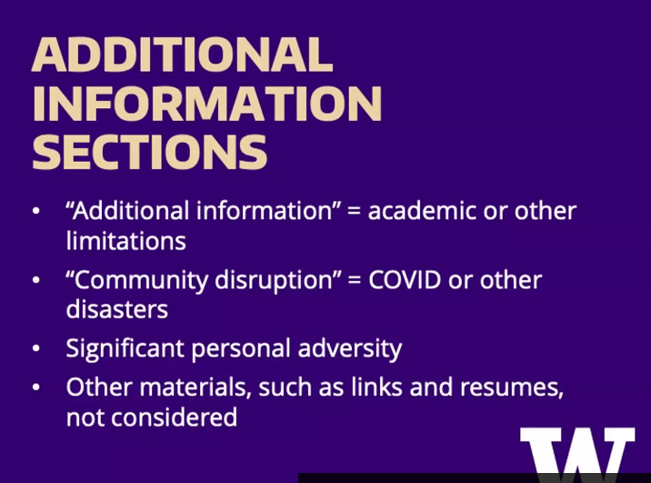
Additional information: don’t add links to additional portfolio like linkedin
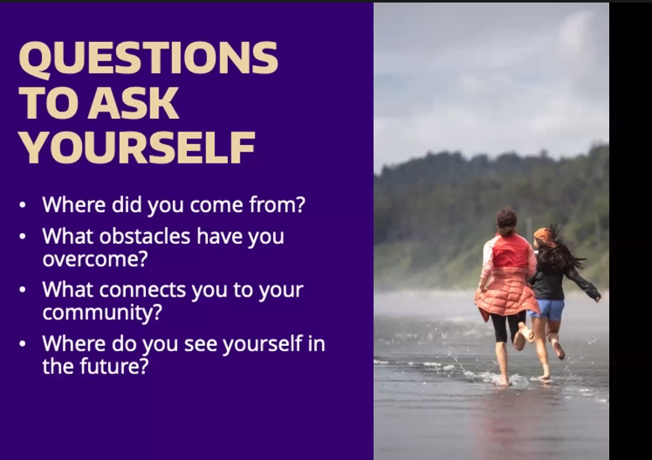
“how does that impact you as a person”
“you don’t have to trauma dump” show what obstacles u passed
Creativity, ingenuity, care = characteristics to try to demonstrate
Community:
Where do your passions lie
Where do u spend most your time
What will u bring to UW
Goals:
- Career
- College
- High school graduation

Some ideas: 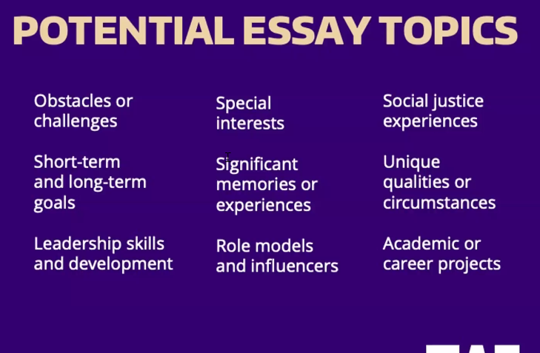
“family, caregivers, translators” whats your role like in a family?
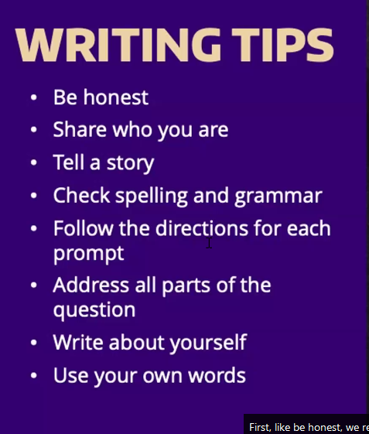
They can tell when the students are being authentic

“show” the how and the why and the what
Use your own voice b/c that helps authentic voice

UW doesn’t look at the common app essay

“speak to being a part of ethnic group > affects to cultural awareness > challenges overcome” (they will consider diverse experiences even with the new law)
UW’s statement about diversity essay: https://www.tacoma.uw.edu/legal-pathways/diversity-statements

“when you say make the essay very ‘YOU’, would you say that writing about someone that has impacted us such as a sibling or parent work? it won’t be specifically about that figure, but more how they impacted us.”
>you are allowed to do that as long as it impacted you
>may be hard to give info about yourself
>you need to really talk about the core part of who you are
>talk about yourself a lot more

Don’t try to sound more academic
Try to read a story and then write > theres no real template
“Paragraph writing” is the most efficient way to write
Creativity is good but format doesn’t tell much about u, the content does the most

Word limit: 300-650 words (don’t go over, they won’t see)

What makes an essay stand out?
Guy:
- A common topic but told in a way that “knocks you out of your feet”
  - Metaphor
  - Tragedy \/
- Write about tragedy (we learn who we are in times of tragedy)
  - You don’t have to trauma dump
  - Trauma dumping doesn’t always make a better essay
Girl:
- Brings your perspective and the reflections about the circumstance
  - What happened after, how’d that change you
  - How’d it influence you to grow

What should we not write about?
Guy:
- Its ok if it comes from a soccer game as long as they can see who u are
  - Grit passion leadership opportunity
- Make message clear
- Its bad when u focus on like a medical issue without focusing on yourself
- Abuse/neglect; they need to report that
Girl:
- You can make a good story from a common topic if it shows personal experiences best
UW rarely considers SAT ACT (unless u are international)
Prompts don’t change often, they update it on their website
U can check a box that asks to be in an honors program: https://honors.uw.edu/apply/

Ask qs here: 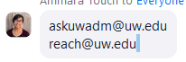

Counselors that may help and give feedback on essays:
https://admit.washington.edu/contact/counselors/

writing essay info: https://admit.washington.edu/apply/freshman/how-to-apply/writing-section/

Last year’s recording: (“same content”)
https://www.youtube.com/watch?v=-XPJfSYBYDo

short response: mostly community highlight
jobs, sports, clubs
family commitments, translating

they are more focused on essay than on letters of rec, and very tiny on sat act

UW will join common app (but not same essay/prompts)

(stopped taking notes in 10 min mark)
(skipped to faq, 38 min mark)

SAT scores is only considered if u weren’t going to get selected but then had a good score. It doesn’t really disadvantage you (for this school)

Other Notes
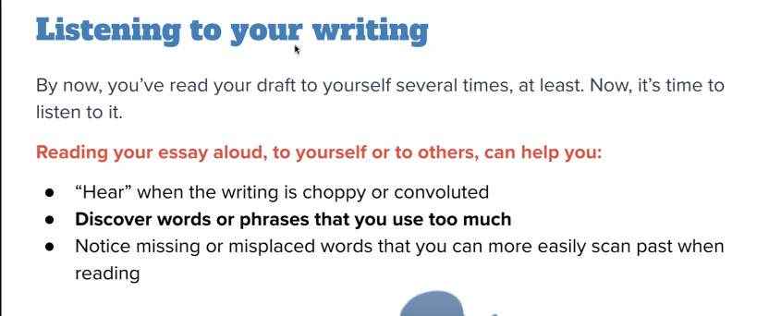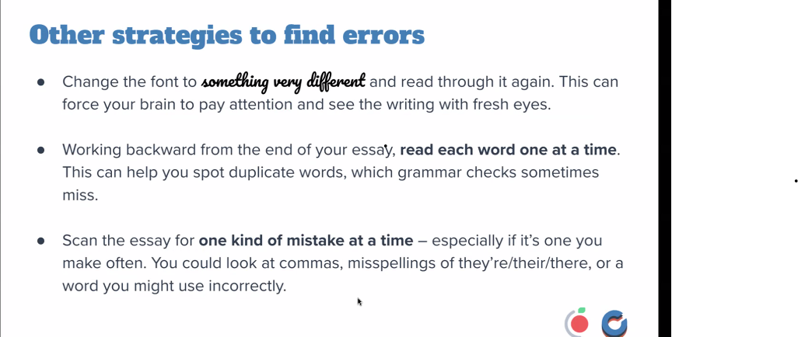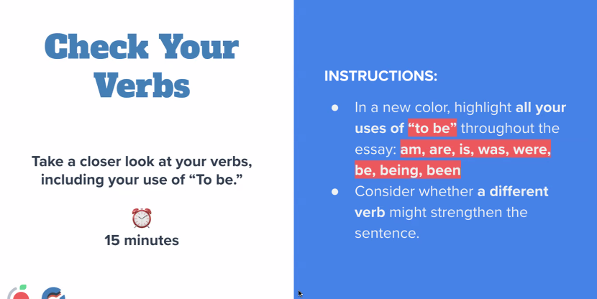
They’re looking to see if you are socially intelligent. To do this, u can show leadership empathy etc

The essence objects should represent you or your memories or connections

No need for a neat little bow
Describe the world from a perspective u are very passionate about and nerd out

Why us?
- Mention your mission statement
- Where it is and if u are prepared for it
- What prepared u for this major

Dont be vulnerable just for the sake of being vulnerable- do it if you sound more relatable or likeable, or it explains why you did something not understandable/good

Replace all the unnecessary adjectives with more “showing”. Also use action verbs

75 words challenge and effects
250 what you did
100 what you learned

https://www.youtube.com/watch?v=n_27pcHIq0o rlly good video for tips on story writing overall + more specifically college essay writing

if you didn’t connect your major back to you: do the qualities you present match what the college wants from this major? Like someone may want someone creative for CS

When writing a diversity essay: If u talk about your family, it will be hard to mention how u will be brining that family diversity into UW considering u are likely moving away from your fam

Passion essay: What do you love and why do YOU love it? Imagery helps! What do you do to show your love?

Use alliteration, similes and metaphors

UW likely knows about CSRSEF, but other schools may not. Don’t waste your words by spelling out the abbreviation, maybe just say science fair or smthng

Your opener isn't just your first sentence.

"suddenly clarity came to me" - lazy writing mistake. explain how u come a conclusion. Dont have "divine inspiration" or "eureka moments"

If you are struggling with the conclusion and the main theme of your whole essay, think of the purpose of each paragraph. What traits and lessons are u trying to show? Whats the underlying importance of your story?

Conclusion is a part of the story. Don’t make it a repetition, but a “bring final meaning and wrapper” to the story.

As ms fort said: You loved school! You’re ready for more school! (if you talk about how you hated school in your essay, they may see you as unfit for the college life. Unless you can show immense growth and change in beliefs, don’t write about how stressful your sophomore year was, okay?)

This vid: https://www.youtube.com/watch?v=PfRBWckNLLg

Ms fort tip: Don’t write about fundraising bc its not really “real” where u do stuff… (unless there’s physical action or direct engagement, won’t be interesting to read)
Also good essays have 0 academics (like no school projects or I got 5s on all APs)
AND its ok if writing sounds robotic and not flowery. Write how you like to write.
You can simplify detail, its ok. Not every table u mention u sat on has to be explained its heritage story. CUT OUT ADVERBS (like Stephen King has said). They usually end with -ly, and modify verbs or adjectives: “hastily”, “loudly”, “very”. Instead, use stronger verbs instead of adverbs: no “she ran very fast”, instead say “she bolted” (saves words, and is better!)

to shorten writing:
- Remove unnecessary details and adjectives
- Dont overdo imagery- make sure to leave enough words to describe YOU
- Just writing in your stream of consciousness may bring unnecessary sentences. If you split the sentence, would you still deem it necessary?
- Rewrite it. Things u didn’t even notice weren’t necessary or could be optimized suddenly seem more clear

